 | Operator’s Handbook
Oxford LabVIEW
System Control Software
Version 5.x.x : LabVIEW 5.x, 6.x, 7.x required
Version 3.x.x : LabVIEW 3.x, 4.x, 5.x required
Issue 15
November 2026
File reference: 0000.doc
Oxford Instruments  Superconductivity  Tubney Woods, Abingdon,  Oxon, OX13 5QX, England  Tel: +44 (0)1865 393 200  Fax: +44 (0)1865 393 333  E-mail:superconductivity@oxinst.co.uk  www.oxford-instruments.com |  | 

Contents
1 Introduction and System Requirements 4
1.1 LabVIEW Versions 4
1.2 Computer 5
1.3 GPIB 5
1.4 Serial Ports 5
1.4.1 Serial Ports on a Macintosh 5
2 Installing the Software 6
2.1 PC Installation 6
2.2 Manual Installation 7
2.3 Macintosh and Unix Installation 7
2.4 Post Installation 7
3 How to Start the Software 9
4 Configuring the Instruments 11
4.1 Communication Principles 11
4.2 Communications Parameters 14
4.2.1 To Set the ISOBUS address of an Instrument. 14
4.3 Step by Step instruction on Configuring and Running an Instrument VI 17
4.3.1 Open the Instrument Setup Dialog VI 17
4.3.2 Enter values for the Communication Parameters 19
4.3.3 Enter values for the rest of the Setup 19
4.3.4 Save the Setup 19
4.3.5 Open the Instrument Front Panel VI 19
4.4 ITC PID Table Setup 19
4.5 ISS AutoShim Table 19
5 Graphing, Logging and Log Analysis 20
5.1 How to use GeneralMonitorSetupDialog.VI 20
5.1.1 Adding a Signal 21
5.1.2 Removing a signal 21
6 Programming with the VIs 22
7 Troubleshooting 23
7.1 Isolating communications problems 23
7.2 GPIB Problems 25
8 Teslatron or B/T Environment Software 26
8.1 Introduction 26
8.1.1 Teslatron or B/T System Manager 26
8.1.2 Sequencer 26
8.1.3 Fridge 26
8.1.4 Interlocks 26
8.1.5 Self Test 26
8.2 Configuring the Software 27
8.2.1 Teslatron or B/T SetupDialog 27
8.2.2 Fridge Setup Dialog 27
8.3 How to Use the Software 27
8.4 How to Build Your Own Application 27
9 Heliox 28
9.1 The Heliox panel 28
9.2 The Recondense VI 28
9.3 The Heliox Setup 29

Introduction and System Requirements
© Oxford Instruments Superconductivity Limited, November, 2026. All rights strictly reserved.
The Oxford Instruments LabVIEW System Control Software provides control and monitoring of the Oxford Instruments range of superconducting magnets and ultra-low temperature systems ie He³ and dilution refrigerators.
The software consists of low level drivers for the different electronic instruments and the higher level applications that build upon the low level drivers to perform system specific tasks and routines.
This manual describes how to install, configure and use the software and has been written using PC rather than Macintosh terminology. Although most operations are the same for both platforms, you should note that control key operations involving the PC ctrl key should be performed on the Macintosh with the Apple  key. If additional support is required for the general operation or programming of LabVIEW, please contact National Instruments.

LabVIEW Versions
The release number of your software is given in the file readme.txt on the CD (in the directory DrvDisk1), as well as on the label of the CD. The LabVIEW versions used for the more recent Teslatron or OXSOFT releases are listed below.
Teslatron or OXSOFT release | LabVIEW version
Version 5.x.x  This software can be loaded into LabVIEW 5.x and 6.x  Currently supported version (at the time of editing, version 5.0.7) | Written using LabVIEW 5.0
Version 3.9.1  This software can be loaded into LabVIEW 3.1, 4.x and 5.x  Unfortunately, this version of the software is no longer under development.  Must run SetOptions.vi in Install.llb | Written using LabVIEW 3.1
Table 1- LabVIEW versions

Computer Specification

- SVGA graphics (800 × 600 pixels @ 16/256 colours)
- 166 MHz Pentium II Processor running Windows 95 (or later)
- 32 megabytes RAM + virtual memory (at least 64Mbytes for Windows 2000)
- Minimum of 30 MB of free hard disk space
- CD Drive
- A mouse, if COM1 and COM2 are allocated for other purposes then a bus mouse is recommended
The OXSOFT or Teslatron Installer software has been written to CD using a PC. If another type of computer system is used eg Macintosh or Unix, then steps to read the CD initially will have to be taken by the operator.

GPIB
We currently support GPIB cards from National Instruments only. If you are using GPIB communication then it is important that you choose a GPIB card compatible with LabVIEW, the operating system you are using, and that LabVIEW itself is installed with the correct options. Please consult National Instruments or the LabVIEW user manuals for details if necessary (an AT-GPIB is also compatible with Oxford Instruments' ObjectBench software). Please ensure that the GPIB driver from National Instruments is installed, configured correctly and the computer operating system recognises the card.

Serial Ports
Communications with Oxford Instruments’ instruments can also be performed over an RS232 serial link. The Oxford Instruments ISOBUS system allows many instruments to be connected to a single serial port with each instrument having a unique ISOBUS address (ISOBUS address is simply a number between 0 and 9). However, if you are using an AVS47 or AVS46 via a picobus cable (supplied with many Kelvinox systems) you will require an additional dedicated serial port for this instrument.

Serial Ports on a Macintosh
There are two ports on a standard Macintosh to which the ISOBUS may be attached: the Modem Port and the Printer Port. Within LabVIEW (in particular the setup dialogs for each of the instruments) the :
Modem Port is equivalent to Com 1 on a PC
Printer Port is equivalent to Com 2 on a PC
An adapter lead is required to link the mini-DIN connector on the Macintosh to the 25 way D connector on the ISOBUS. This should be supplied with the ISOBUS cable. Note that the ISOBUS cable itself is a modified version of the ISOBUS cable supplied with PC systems in order to make it level compatible with the serial ports on the Macintosh. Older ISOBUS cables will not work with the Macintosh.

Installing the Software

PC Installation
If the target computer is a PC then the following procedure can be performed using the VI PCInstall.VI in the LabVIEW file Install.LLB in the directory DrvDisk1. Please follow these steps to install the software.
- Start LabVIEW.
- Open a VI (Virtual Instrument) : File | Open – a dialog box should appear.
- Select “CD drive”\”Tesl...” \DrvDisk1\Install.llb\PCInstall.vi. where … is the software version number (please use the most recent version).
- 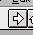The following window will appear.
Click arrow to run installation
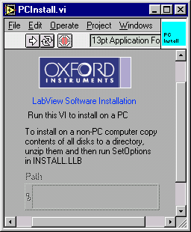
- Run the software by using the mouse to press/select the arrow (indicated above)
- A dialog will appear asking you to select a location to install the software. Please select a new directory on the computer hard drive.
- Another dialog will appear asking which components of the software you would like to install. Please select the components relavent to your system (not all components are included with all installations)
- The software will now copy files from the CD drive to your computer hard drive – these are zip files.
- Following this, a window will appear to extract the zip files. Once the files have been unzipped a message will be shown saying “Close this window and continue with the installation”. Please close the window.
- Then select “Continue” on the dialog displaying the message “Press continue when unzipping has finnished”
- A readme dialog will now appear. Press OK
- Finally, at the end, the software will be mass compiled to the version of LabVIEW you are using. This compiling operation will make the software execute more efficiently. Once the compiling has started, please be patient until the process has completed and a menu dialog is presented to you. At this point, the installation is complete and the user can setup the instruments and system software as required.

Manual Installation
The software is distributed as a set of LabVIEW library files (extension LLB) which have been compressed using PKZIP, combined with other small initialization/documentation files which are un-compressed. Installation involves the following:
- Copying all the zip files from the CD into a new single directory on the computer (this can also be done from floppy disk or the World Wide Web).
- Uncompress each zip file and extract the contents to the same directory as the zip file. This will ensure that all the software stays in the same directory.
- For older versions of the software that are no longer supported (version 3.9.1 or older), please run SetOptions.vi in Install.llb. This is not necessary for later versions.
- If the software has been copied from a CD, please ensure that the setup and initialization files (*.ini or *.dat) are not “Read Only” files.
If you are re-installing the software, you should retain the old setup information by installing the updated software in a new directory and then copying your old setup files to this new directory. The setup files are small initialization files which have extension .DAT or .INI (eg tesltron.ini, kelvinox.ini, heliox.ini … etc.)
If you are experiencing problems with the installation routine described in section 2.1, this manual installation can be used instead.

Macintosh and Unix Installation
For Macintosh and Unix operating systems, the easiest way to perform the installation is to perform the manual installation described above. Please ensure that you have setup files representative of your system.

Post Installation
When first using the installed software you will probably be asked to save changes when closing VIs. This is due to the version of LabVIEW or the computer platform you are using is not the same as that used by Oxford Instruments to write the software. You should answer affirmatively as this will save time when the software is next loaded and the code will execute more efficiently.
After installation you should keep the original installation disks or CD in a safe place, away from magnetic fields. When using floppy disks please write-protect each disk to prevent accidental overwriting of the software.

How to Start the Software
Start LabVIEW and run the virtual instrument (VI) called OIMenu.VI in the LabVIEW library file OIMENU.LLB. This allows access to all the Oxford Instruments software drivers installed on the computer. The menu allows the operator to setup the instruments communication parameters, launch the instrument drivers, execute system control software (where applicable) and start monitoring software to follow trends e.g. helium usage.
Click here to switch menus.

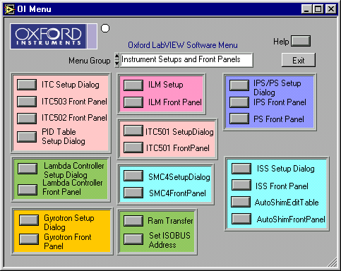
Figure 1 OIMENU.VI (oimenu.llb), the menu entry point to all other VI's
Note : Context sensitive help is available by use of CTRL-H (or  -H on a Mac) to open the help window which will display help on the control covered by the mouse pointer.
Note LabVIEW allows the user to stop a VI unconditionally i.e. immediately by clicking on a stop symbol, or typing ctrl-. (control + period). This should be avoided in general, since it bypasses the normal program flow. Another useful key combination is ctrl-m which switches to edit mode. This may be necessary occasionally to obtain a menu bar. As a last resort, VIs that are not responding can be terminated by using the VI window menu at the top-left of the window (type alt-spacebar). Choose Switch to... and then End task. This will cause LabVIEW to exit.
With LabVIEW in edit mode, it is easy to make small inadvertent changes to a VI. A button or LED can be moved slightly for example. If this happens, LabVIEW will then ask if you want to save the VI when you try either to close it or to exit from LabVIEW. Unless the changes were deliberate, you should say No, and the changes will have no permanent effect. Sometimes your installation choices will force recompilation of VIs and you will be asked to save them even though you have not made any changes. In this case, you should save the VIs to avoid being asked the question.
It should be noted that any programming modifications to the standard drivers supplied by Oxford Instruments will not be supported (other than saving the vi’s to the version of LabVIEW the customer is using)

Configuring the Instruments
Each instrument requires configuration within the software before the drivers can be used. The configuration includes the instrument remote communication parameters, a device name and type, along with possible system control parameters. This information is entered using the instrument specific setup dialog which is accessible via OIMenu.VI in OIMENU.LLB eg IPS/PS Setup Dialog for IPS/PS (PSSetupDialog.vi), or ITC Setup Dialog for an ITC (ITCSetupDialog.vi)
The setup information is stored in initialization files (*.ini) eg tesltron.ini, igh.ini, kelvinox.ini … etc. These should be edited using the Setup Dialogs for each instrument that can be launched from the OIMenu.vi. It is not recommended to edit these files by hand as the text is not always easy to interpret.
For each of the instruments follow the instructions given in section 4.3.

Communication Principles
To remote control/monitor Oxford Instruments electronic devices eg ITC, IPS, ILM … there are some simple steps that must be followed.
- Decide on the method of communication for the instrument eg RS232, GPIB, ISOBUS or GATEWAY and use the appropriate cabling.
- Find or assign an address to the instrument in question (ie ISOBUS or GPIB addresses).
- Enter the communication parameters into the software on the PC for the instrument in question.
- Start the software driver for the instrument.
There are four methods of communicating to Oxford Instruments electronics : RS232, ISOBUS, GPIB, and GATEWAY.
RS232 communication is also known as serial communication and requires a single cable between the COM port of your computer and the instrument. For this method of communication, you only need identify the COM port on your computer.
ISOBUS is similar to RS232 and uses a unique ISOBUS cable made by Oxford Instruments. This ISOBUS cable allows a single COM port on the computer to be connected to multiple Oxford Instruments electronic devices in a daisy chain manner. One adapter (master) connects to the computer COM port and the other adapters (slaves) connect to the back of the electronic devices (RS232 connector). Each instrument has an ISOBUS address that is stored in the instrument memory and this ISOBUS address must be unique to each instrument connected to the ISOBUS cable. Communication to each device is then achieved by knowing the ISOBUS address of each instrument in question and the computer COM port the master plug is connected to.
GPIB communication is a well known method of controlling hardware. This requires a GPIB card (we only support GPIB cards from National Instruments) to be installed in a computer (with the necessary driver software installed), a GPIB cable and the GPIB interface to be fitted to the electronics in question. One end of the GPIB cable is connected to the GPIB card of the computer and the other to the back of the device. For multiple control of devices, another cable can then be connected in a daisy chain manner to another device. For this method of communication, you require the GPIB address of each instrument.
GATEWAY communication to devices is a combination of GPIB and ISOBUS technology. The computer is connected via GPIB (described above) to an instrument (known as the GATEWAY instrument). A small adapter (called a GATEWAY adapter) is then connected to the RS232 port of the GATEWAY instrument. The ISOBUS cable master adapter subsequently connects to this GATEWAY adapter and the other slave connectors of the ISOBUS cable connected to other instruments RS232 connectors (on the back of each instrument). With GATEWAY devices, the command is sent to the GATEWAY instrument via GPIB. However, the command is then relayed to the other instruments on the ISOBUS cable. For this method of communication you require the GPIB address of the GATEWAY instrument and the ISOBUS address of the instrument connected to ISOBUS cable.
Examples of these communication methods are shown on the next page.
Computer COM1
COM2
COM3
ITC
IPS
ILM
Computer COM1
ITC – ISOBUS address 1
IPS – ISOBUS address 2
ILM – ISOBUS address 6
ISOBUS cable
Master adapter
Slave adapter
Slave adapter
Slave adapter
Computer COM1
ITC – ISOBUS address 1
IPS – ISOBUS address 2
ILM – ISOBUS address 6
ISOBUS cable
Master adapter
Slave adapter
Slave adapter
Slave adapter
Computer GPIB Card
ITC – GPIB address 24
IPS – GPIB address 25
ILM – GPIB address 27
GPIB cable
GPIB cable
GPIB cable
Computer GPIB Card
GPIB cable
ITC – GPIB address 24
ITC – ISOBUS address 1
IPS – ISOBUS address 2
ILM – ISOBUS address 6
ISOBUS cable
GATEWAY adapter
Slave adapter
Slave adapter
Slave adapter
Master Adapter
RS232 Communication
GATEWAY Communication
GPIB Communication
ISOBUS Communication

Communications Parameters
The type of communication link must be specified, and in the case of multi-instrument buses eg ISOBUS or GPIB, uniquely identify all instruments that are sharing the link. With version 5.x.x of the Oxford LabVIEW drivers, it is possible to mix the communication method between RS232, ISOBUS, GPIB and GATEWAY as the operator requires. With older versions of the Oxford Instrument drivers, your choice of GPIB or ISOBUS libraries at installation time selects the primary link from the computer to the instruments and the bus types can not be mixed eg ISOBUS (not GPIB) or GPIB (not ISOBUS).
To uniquely identify each instrument the software must know how and where to communicate with the instrument in question. This requires two steps.
- The first step is to try and identify or set the address of the instrument. The two addresses in question are called the ISOBUS address and the GPIB address. The ISOBUS address can only be set using software (using Set ISOBUS address described in section 4.2.1). The GPIB address can only be set by entering the Test procedures for the instrument in question (please consult the instrument manual). Please select unique ISOBUS or GPIB addresses for each instrument (instruments with the same address will result in corrupt communication and data errors). This affects the address if the instrument internally and has no reference to the computer software.
- Alternatively there is a tool which searches for instruments connected to your PC. Using LabVIEW, open and run the VI called “Search for Instruments.vi” in Instrum.llb. Select the method of communication and search for instruments. This small utility will report the addresses of any device connected to the PC. If “Device conflict” appears, it implies that there are two instruments connected that have the same address. The address of one of the devices should be altered in this case. Please take note of the addresses of the instruments detected as you will require the information for the setup dialogs of the instruments.
- Once the addresses of the instruments are known, the software communication parameters within the computer LabVIEW software must be set to the same values as the instruments. These parameters are entered via the setup dialog VI’s launched from the main OIMenu.vi. At this point this is simply a software configuration, and does not affect the instrument itself.
Table 2 lists the different interface configurations and the values of the different interface parameters for each. Non-zero addresses are examples only and can be any unique number. Table 3 indicates the default ISOBUS addresses for our instruments.

To Set the ISOBUS address of an Instrument.
Each of Oxford Instruments electronic devices eg IPS, ITC, ILM…. have an internal ISOBUS address (similar to a GPIB address). The ISOBUS address is simply a number between 1 to 9 and must be unique to each device ie to each IPS, ITC, ILM etc. and can only be set using software commands. In order to use a computer to control many devices from a single COM/RS232/Serial port of a computer, you can use an ISOBUS cable along with the ISOBUS addresses of all the instruments.
To assign an ISOBUS address to a device, please select “Set ISOBUS address” from the OIMenu. This will open a LabVIEW VI called SetISOBUSAddress.VI. Enter the required values for the communication parameters. Select OK and follow the instructions (Note : please ensure that no other instruments connected to the ISOBUS cable are turned on, otherwise the software will attempt to set all the instruments connected to the ISOBUS cable to the same ISOBUS address)
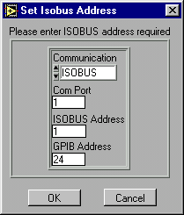

Instrument Interface | COM Port | ISOBUS |  | GPIB
Direct serial link to computer.  Communication : RS232 | No of com port used. | -1 |  | N/A
ISOBUS directly to computer.  Communication : ISOBUS | No of com port used. | Enter the ISOBUS address of the instrument. |  | N/A
ISOBUS which is connected via a gateway instrument  Communication : GATEWAY | N/A | Enter the ISOBUS address of the instrument |  | GPIB address of the gateway instrument
GPIB only.  Communication : GPIB | N/A | 0  There is no need to set the ISOBUS address in the instrument to 0 however as the firmware will only respond to ISOBUS 0 when interfaced via GPIB |  | GPIB address of instrument
Instrument is a gateway instrument. (GPIB to computer and Gateway unit to ISOBUS)  Communication : GPIB | N/A | 0  There is no need to set the ISOBUS address in the instrument to 0 however as the firmware will only respond to ISOBUS 0 when interfaced via GPIB |  | GPIB address of instrument
AVS connected directly using PICOBUS to PC com port | No of COM port used | N/A
AVS connected using an AVS47-IB | n/a. For Picobus address use the default of 1 |  | GPIB address of instrument
Table 2 Possible interface configurations and the associated communication to be entered in Setup Dialog VI’s. N/A stands for “Not applicable” in which case the value is not used .
Instrument | Address
ITC502/503 | 1
PS120/IPS120 | 2
Lambda controller | 3
SMC4 | 4
IGH | 5
ILM200 | 6
ISS10 | 7
Table 3 Default ISOBUS addresses

Step by Step instruction on Configuring and Running an Instrument VI
This information is relevant for any of the following instruments: IPS, PS, ITC501, ITC502, ITC503, ITC601, ILM, ISS, SMC4, SMC1, Lambda Controller, Gyritron Controller, IGH, AST Controller.

Open the Instrument Setup Dialog VI
Open the appropriate instrument setup dialog from OIMENU.VI . For example for an IPS or PS open IPS/PS Setup Dialog (PSSetupDialog.VI) as shown in Figure 1. The Setup dialog for the power supply (IPS) is shown below.

The Help Window opened using the CTRl-H short-cut.
Communication Parameters
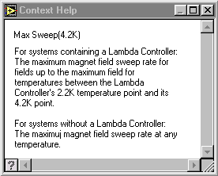
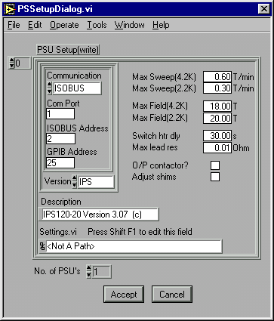
The Array Indexor. (0,1,2,…) See text for more information.
Convenient name of IPS
Magnet details
Number of relevant entries in the setup array.
Press to discard all changes.
Press to save the setup information

Figure 2 The PSSetupDialog.VI and the Help Window showing help on the item Max Field (4.2K) obtained by using the CTRL-H short-cut and moving the mouse over the Max field (4.2K) control.
The main element of any SetupDialog VI is the Setup Control in which information for an instrument is entered. Having entered the information for the instrument in the Setup Control press the Accept button to save the settings.
In figure 2 there are two extra elements: the Indexor and control labelled “No. of PSU’s”. For the cases of ITC’s, IPS/PS’s and ILM’s one may need to enter information for more than 1 instrument, e.g. the Heliox system can use 2 ITC’s. In such cases enter the information for the first ITC or IPS/PS into the Setup Control with the Indexor set to 0 and then change the Indexor to 1 to enter the information for the 2nd instrument; finally set the No. of PSU’s control to 2 before pressing the Accept button to save the changes to file.

Enter values for the Communication Parameters
Using the information in section 4.2 you need to decide on relevant values for Communication, COM port (if applicable), ISOBUS address, and GPIB Address (if applicable) and then enter them into the controls shown in Figure 2. e.g an IPS acting as a GPIB gateway at GPIB address 25 would have values COM port (not applicable), ISOBUS address(0) and GPIB address(25).

Enter values for the remainder of the Setup
Using the on-line help to guide you (CTRL H), enter values for the other parameters in the Setup control (system parameters)

Save the Setup
When you are happy with the setup parameters use the Accept button to save the settings. Close the SetupDialog.VI window using File | Close command.

Open the Instrument Front Panel VI
Once the communication parameters have been entered for the instruments, press the relevant button on OIMENU to open the FrontPanel Vi for the instrument. e.g. for an IPS press the IPS FrontPanel button. If the communication parameters are correct, the VI will put the instrument into remote control and live data will be displayed on the software.

ITC PID Table Setup
Certain applications, such as Heliox and Teslatron, can set predefined PID parameters to an ITC when changing the set point temperature. For such applications you need to enter sets of PID parameters for different temperatures using the PID SetupDialog.VI.
Note that the PID table is not used by the ITC front panel (software). When a temperature is set from here, the PID values of the instrument are unaffected, except in the case of an ITC503 in Auto PID mode when appropriate values will be set from the instruments internal PID table in the usual way.

Graphing, Logging and Log Analysis
Values of signals from temperature controllers, level meters and power supplies can be monitored and logged using GeneralGraph.VI in Graphs.LLB. Before starting this VI for the first time configuration data should be entered using GeneralMonitorSetupDialog.VI as described in section 5.1. On-line help for the different controls on the VI is available in the Help window (Keyboard : Ctrl H)
Log files produced by the General Graph facility and other applications can be analysed using the AnalyseData.VI in ANALYSIS.LLB. On-line help is available on the Help window and via the Help button.

How to use GeneralMonitorSetupDialog.VI
The Signals Indexor (0,1,2,3)
Individual Signal information

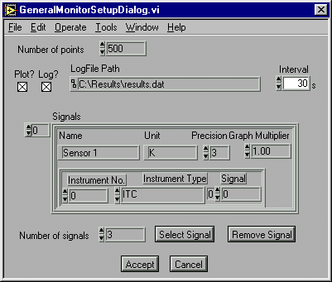
Values set using the Select Signal button.

Figure 3 GeneralMonitorSetupDialog.VI in GRAPHS.LLB. Use this VI to specify which signals to be plotted by GeneralGraph.VI
On-line help for the different controls on the VI is available in the Help window.
The control labelled Signals is a LabVIEW array of individual signal information (it’s value ranges from 0 to n-1 where n is the number of signals). To view and edit information for a signal change the value of the Indexor; note that the first signal information is shown when the Indexor is 0.

Adding a Signal
If the number of signals already defined is n then set the Indexor to n and change the Number of Signals control to n+1. Press the Select Signal button which will open the SelectSignal.VI. Follow the instructions on SelectSignal.VI to specify the instruments and signal required. On returning from SelectSignal some controls in the Signals control will have been changed. You must now edit the controls Name, Unit, Precision, GraphMultiplier to complete the signal specification.

Removing a signal
Change the Signal Indexor until the Signals control shows the information for the signal to be removed. Press the Remove signal button. After that decrease the Num of Signals control by 1.

Programming with the VIs
The real strength of the software is the way that its functionality has been packaged into modules that can be called from LabVIEW programs developed by the user. Third party instrument drivers are available, which, together with the drivers supplied by Oxford Instruments, allow creation of custom applications for performing specific experiments.
The VIs are organised into:

- Applications e.g. Teslatron, Kelvinox, Heliox, Graphs
- Instrument front panels - e.g. ILMAPPS, PSAPPS
- Instrument drivers - e.g. ILMSUBS, PSSUBS
- Interface/communication drivers - BUS.LLB
- Utility VIs
See example VI’s in EXAMPLES.LLB for help on how to use the low level drivers. The best way to understand the higher level software is to study the VIs themselves.

Troubleshooting
This section lists some common problems and their solutions. If these do not enable you to resolve your difficulties, please contact Oxford Instruments.
VI ‘Hangs’
There is probably a communications problem due to the cable or communication parameters entered for the instrument – see section 7.1. If the problem does not appear to be communications-related, try re-installing the software.
VI appears to be running but does not respond
First ensure that it is running, by pulling down the Run menu. If the Run command is available as an option (that is, not greyed-out) then the VI is not running. If it is running then it is possible that a sub-VI has been stopped or closed in an abnormal manner. Try reloading this sub-VI to see if it is still running and then exit it using front panel buttons rather than menu options. Se also section 7.1.
Software slow to respond
The Kelvinox software in particular, but all LabVIEW software to some extent, requires a fast processor and a lot of memory to run at a reasonable speed. Even with a well specified machine however, you may find that the Kelvinox VIs are slow to respond. This is simply a consequence of the size and complexity of the software. Apart from increasing LabVIEW’s memory allocation (LabVIEW for Mac and LabVIEW for Windows 3.0.1 and earlier) there is little that can be done apart from upgrading the computer. Do not press buttons repeatedly while waiting for a response – their action is latched which means a single press is always sufficient.
Unable to close a VI
Some VIs are dialog boxes that are launched from a higher level VI, and automatically disappear once they have finished executing. If you load these directly, you may not be able to close them from the menu. To get rid of them, first switch to edit mode by pressing ctrl-m and you will then be able to close them in the normal way.
ISOBUS timeouts
If you press a button on a real instrument front panel while Teslatron is trying to communicate with it, the computer will beep. After a few seconds, if you do not release the button, a dialog box is shown. Release the button and press Continue.
Intermittent communications errors
This can happen if the com port has been incorrectly initialised, in particular if only one stop bit is being used. This can manifest itself either as timeouts even though the instruments are not being interfered with, or Command Rejected errors. All the higher level VIs automatically perform correct initialisation of the com port, but if you load and run a lower level VI directly , or if you have written your own, then it is possible to get into this situation. You must exit and re-start LabVIEW in order to reinitialise the port.

Isolating communications problems
This section gives a step-by step guide to isolating and fixing some of the more common communications problems.
- If the VI is a high level one, such as the Teslatron System Manager, proceed from step 3 with each of the component instruments (temperature controller, magnet power supply etc.)
- If the VI is the Kelvinox Front Panel, particular care must be taken, since the optional AVS requires a special initialisation of its serial port. This can occur even if you do not have an AVS when the appropriate option is not deselected in the setup. Make sure that com ports are correctly assigned to AVS and IGH.
- Disconnect all instruments from their communications lines, except for the one under scrutiny. In the case of Gateway networks however, you must always have the Gateway instrument switched on in order to talk to a slave instrument.
- Switch the target (and Gateway) instrument off briefly, and then on again. Make a note of GPIB and ISOBUS addresses if they appear during startup.
- Load and run the instrument front panel.
- If the instrument front panel runs, then move on to the next instrument and repeat from step 3.
- If the instrument front panel does not run, quit and restart LabVIEW and Windows. This is to ensure that any com ports initialised incorrectly are cleared before investigating further.
- (Instrument Front Panel does not run, AVS instrument)
Load the AVSSetupDialog VI. Check that the com port and Picobus address are correct. The Picobus address will nearly always be 1. Try increasing the Picobus Delay. Check cabling and plugs. Ensure the instrument is correctly configured (in hardware) for the interface type – Picobus, TTL Picobus or GPIB. This is explained in the AVS manual.
Load the VI called BusCommand.VI from the BUS.LLB library. This provides a quick and easy method of checking a particular instrument with different configurations.
- Enter the communications parameters for the instrument directly into the left-hand panel on the VI, and enter a capital ‘V’ into the command section. Run the VI.
- If the VI runs properly, a version message from the instrument will appear in the Reply field. This indicates that the parameters are correct and that the instrument is correctly connected and set up.
- If you have a simple ISOBUS system, enter an ISOBUS address of -1, this will cause the command to be sent out as if without any addressing prefix. If the instrument responds, the problem is with addressing.
- If you have a Gateway instrument then use an ISOBUS address of 0. Disconnect the Gateway Adapter from the instrument so that the computer is only talking to the Gateway instrument. Once you establish communication to the Gateway instrument you will have to use SetISOBUSAddress.VI to set the ISOBUS address of the other instruments to non-zero values before attempting to talk to them using BusCommand.VI.
- If you experience problems talking through the Gateway adapter you can attempt to talk to each instrument individually using its’ serial ports and a 25-way pin to pin ribbon cable to a serial port on the computer.
- If you are using GPIB to talk to the instrument, check you are using the right GPIB address.
- Try swapping cables (GPIB systems) or serial plugs (ISOBUS/Gateway systems) on the target instrument and re-running the BusCommand VI. If you can make the instrument respond in this way then the problem is clearly with the cabling.
- Load and run the SetupDialog for the instrument. Check the settings correspond to those in the BusCommand VI. Adjust the setup if necessary.
- If all the individual instrument Front Panels work, but a higher level VI does not, then make sure that the instruments have unique ISOBUS and GPIB addresses.
- As a last resort, try re-installing the software, before contacting Oxford Instruments.

GPIB Problems
The majority of GPIB problems occur due to incorrect set-up of the driver in the computer.
We recommend the use of AT-GPIB boards rather than the older PC-II as the latter have problems on fast Pentium based computers.
Always use the latest version of the driver. If any diagnostic tests are provided with the driver software for the board then use them.
Oxford Instruments’s VIs do not use DMA transfer or interrupt level processing. It is recommended that DMA transfer is turned off and the IRQ setting set to ‘None’.
On a Macintosh ensure that ‘Extensions’ have been turned on.

Teslatron or OXSOFT (B/T Environment Software)

Introduction
Teslatron or OXSOFT is a suite of software used for controlling a superconducting magnet and variable temperature insert providing:

- Automatic setting of magnet field strength including operation of superconducting switches.
- Automatic setting of shim currents for high field homogeneity magnets.
- Automatic operation of a Lambda Fridge to allow magnet operation at 2.2K for extra high fields.
- System protection from cryogenic level or Lambda Fridge failure.
- Control of variable temperature inserts including automatic setting of temperature controller PIDs.
The modular design of the LabVIEW software allows the user to easily customise the software for their particular experiments.
The major components are as follows.

Teslatron or B/T System Manager
This VI is the main entry point into the Teslatron software. As well as providing access to the other components it also provides direct control and monitoring of a single magnet and insert temperature controller.

Sequencer
This VI allows the user to specify a sequence of magnet strengths and insert temperature for a particular experiment.

Fridge
The Fridge VI automatically adjusts the Lambda Fridge valve to attempt to maintain the magnet temperature below the user specifiable target temperature.

Interlocks
The temperature of the magnet as well as the helium level is monitored and if required the magnet current reduced to within allowed limits.

Self Test
The Self Test checks that the interface to all the equipment works and that the magnet lead resistance is OK. It is recommended that you run the Self Test before any other software as it may interfere with software operation.

Configuring the Software
First configure the different instruments as described previously.
Access to the setup dialogs to be used to enter Teslatron or B/T configuration data is provided via the OIMENU.VI in OIMENU.LLB.

Teslatron or B/T SetupDialog
This contains the basic information needed to run Teslatron.
Note that On-line help is available on the Help window.

Fridge Setup Dialog
Information required if a Lambda Fridge is present on the system.
The Fridge VI has two pressures it tries to maintain, the Upper Pressure for when the magnet temperature is above the target and the Lower Pressure for when the magnet is at or below the target temperature.
The Deadband prevents continual hunting of the valve. If the actual pressure is within the Deadband of the required pressure no adjustment of the valve is made.

How to Use the Software
Use OIMENU.VI to open B/T System Manager. As selected in the TeslatronSetupDialog.VI this VI will perform a self test, start the interlocks VI and the fridge VI.
Use CTRL-H and move the cursor over the element of the VI of interest to view the context sensitive on-line help.

How to Build Your Own Application
The vi’s SetDemo.vi in Tesltron.llb and RampDemo.vi in Ramp.llb are examples of applications which automate the use of Teslatron. With inclusion of your own measurement vi these can easily be customised into useful applications.; especially when combined with use of the General Logging VI described in section 5.
For advice on customising the software please contact Oxford Instruments.

Heliox
The Heliox suite of VIs provides a mimic front panel image of the system and lower level tools to run an Oxford Instruments Heliox system. For an explanation of the terminology used here, please consult the Heliox manual.

The Heliox panel
The Heliox Front Panel is opened via the Applications panel of OIMENU.VI in OIMENU.LLB. This panel provides access to all other features of the Heliox software and must be running at all times if automatic recondensation is required.

The Recondense VI
The recondensation process can be initiated either by the user using the Condense button on the Heliox Front Panel.vi, or automatically according to conditions entered in the Setup dialogue. The objective of the condensation process is to liquefy as much as possible of the 3He charge.
The basic procedure consists of heating the sorb and then waiting for the 3He pot temperature to drop below a specified threshold level. This is then repeated with a different set of 3He target temperature and 1K pot needle valve. The purpose of the second part is to allow the 1K pot to be run in single shot mode thus creating lower temperatures. Following condensation the sorb is then cooled rapidly to a value at which it can be used to control the pot temperature.
In a non-fully motorised system the settings of the needle valves must be perfomed manually.
In Figure 4, a schematic representation of sorb and pot temperatures is given over the time taken to recondense the 3He. The temperatures T(1) and T(2) are threshold values defined in the Heliox setup and discussed in more detail in that section.
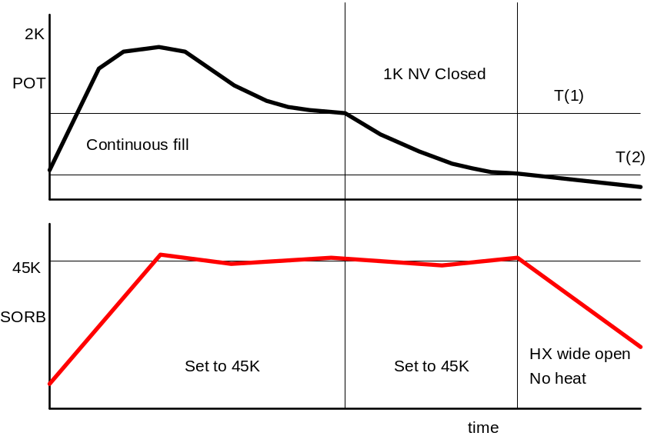
Figure 4 - Sorb and pot temperatures during condensation

The Heliox Setup
Most of the functionality of the Heliox software comes from knowledge of the physical locations of sensors and needle valves. This knowledge is provided through the setup VI.
First setup the ITC using the ITCSetupDialog which is described elsewhere. Subsequently use the Heliox Setup Dialog via the OIMENU.VI to enter system parameters for the Heliox itself.
The setup parameters are divided into groups according to their function. On-line help is available by hitting ctrl-h. The Help window will provide additional information regarding the input field closest to the mouse pointer.

Note that this will not work if the VI is being called by a higher level VI – you must stop the highest level VI of the hierarchy.

